Wheelchair Skills Program
Video-Feedback Service
What is it?
This is a service that the Wheelchair Skills Program of Dalhousie University is offering on a trial basis. It is intended for wheelchair providers (e.g. a therapist or therapy student) or an instructor of a wheelchair provider. The goal is to provide feedback on a video of a person attempting a wheelchair skill (the “Service”).
Conditions
- You agree that you will first take advantage of the free online learning materials in the Wheelchair Skills Program (WSP) Manual and the instructional videos about the skill on the WSP YouTube Channel before asking for video feedback.
- Additional Conditions of Use for use the WSP Material apply.
- Some wheelchair skills can be dangerous and result in severe injury if attempted without assistance. You agree to only practice those skills with a spotter (someone who will be available to help prevent injury). Information on how to effectively spot can also be found on this website in the WSP Manual and the instructional videos noted above.
- You agree that you understand that any feedback provided to you is for the purpose of improving your knowledge, ability and confidence as a wheelchair provider when assessing and training wheelchair users and their caregivers in how to perform wheelchair skills. The Service is not intended for use by unsupervised wheelchair users and their caregivers. Any feedback that we provide is not intended to be used as healthcare advice for a specific wheelchair user or his/her caregiver. Any decision concerning the health, treatment and/or wheelchair of a wheelchair user should be made in consultation with his/her qualified healthcare professional.
- You agree that any data that you provide to us and the advice that we provide to you may be used for research purposes but that you will remain anonymous for that purpose.
- If you send a video to us and we provide you with feedback on it, you agree to respond to a brief follow-up questionnaire that we may use to help us evaluate and develop the service.
- We reserve the right to limit the number of requests per individual.
- Dalhousie University, Nova Scotia Health, the Wheelchair Skills Program and instructors pursuant to the Program, do not make any representations as to the performance or quality of the Service and shall not be responsible for injury or damages arising out of or related to the Service.
- You agree that any person, including but not limited to a spotter, appearing in any video you provide to us, has consented to your taping them and providing us with such recording for use for our research purposes. Accessing the Service by clicking on the provided link and your use of the Service constitutes your acceptance of these conditions and your agreement to be bound by them. By clicking the link provided, and accessing the Service you confirm that you are over 19 years of age.
If you agree to these conditions, please proceed as described below.
To access the Video-Feedback Service, please follow the following steps
- You will need the following:
  - A device for recording a video (e.g. a smartphone or tablet).
  - Internet access.
  - An email account.
  - A YouTube account. This link will describe how to set up an account.
- Inform anyone besides yourself who will appear in the video of the conditions listed on the previous page.
- Record a video of a wheelchair skill attempt. We will only accept one skill per video, but you may separately submit more than one request.
Tips for making a good video
  - If you are using a smartphone or tablet as your “camera”, it may be helpful to have your device in a holder so that your device can be best positioned to show what you want. Such holders can be purchased but a simple and inexpensive holder can be created for a smartphone by cutting notches in a disposable drinking cup. The photographs below show the materials needed (left), the shortened cup with the slots cut into it (center) and a cellphone case in the camera-holder (right).

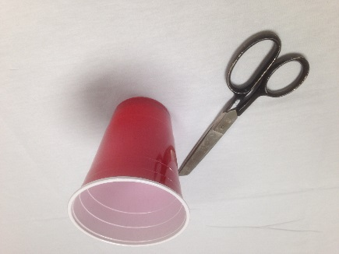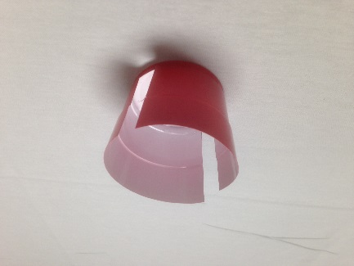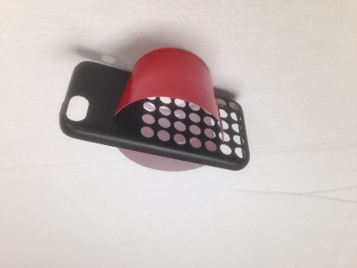

- As an alternative to having the camera in a holder, having another person available to act as a “cameraperson” can be helpful.
  - Choose a well-lit, quiet, safe and private space.
  - Choose the best camera angle to show what you want. For a wheelchair skill, this is usually a side view.
  - Hold the camera in the landscape (horizontal) position.
  - Hold the camera at a comfortable sitting or standing height, rather than placing it on the floor.
  - Make sure that only the wheelchair user and caregiver are in view. Avoid having anything in the background that you would prefer not be seen, such as other people.
  - The camera should be at a distance away that the wheelchair, the wheelchair user and the caregiver fill about one-half of the screen.
  - If the skill is a moving one, the cameraperson may need to move the camera to keep the moving wheelchair in the field of view.
  - If you are the person recording the interaction:
    - To avoid missing anything, it is good practice to start the video-recording a few seconds before the skill attempt and to stop the recording a few seconds after the attempt has been completed. It is better to have the recording be a little too long than a little too short.
    - Review your video-recording right away after filming to ensure that it clearly captures what you want and that it does not accidently include other people in the background.
    - If you are recording more than one skill, it is better to create a series of short video-recordings than one long one.

- Post the video on YouTube. We suggest that you use the “unlisted” function if you only want the video to be seen by people (like us) to whom you have provided the link. Please go to this link to learn what an unlisted video is and how to create one. We are not able to accept videos through email due to firewalls and attachment-size limits. We are not responsible for and disclaim all liability related to your use of YouTube in submitting your video.
- Copy the YouTube link and email it to us at wsp@dal.ca with the words “Video-feedback request” in the Subject line. In the body of your message, please tell us briefly about yourself and what you would like feedback about (e.g., “I am an Occupational Therapy student and I am having trouble getting into the wheelie position [balancing on the rear wheels] as you can see from the attached 15-second video. What should I do differently?”).
- When we receive your email request, we will forward it to one of the WSP Instructors who is knowledgeable about training the selected skill. He or she will review your video and email advice to you. You should usually receive that feedback no more than one week after your email to us. After you receive the Instructor’s advice, you may correspond directly with the Instructor if you have questions.
- After you have received the feedback, you should practice the skill with a spotter while attempting to use the feedback advice received from the Instructor.
- We would welcome your feedback on the process or the advice received.

Cost
At this time, there is no charge for this service, although donations can always be made to the Wheelchair Skills Program Trust Fund (https://wheelchairskillsprogram.ca/en/donations/).

